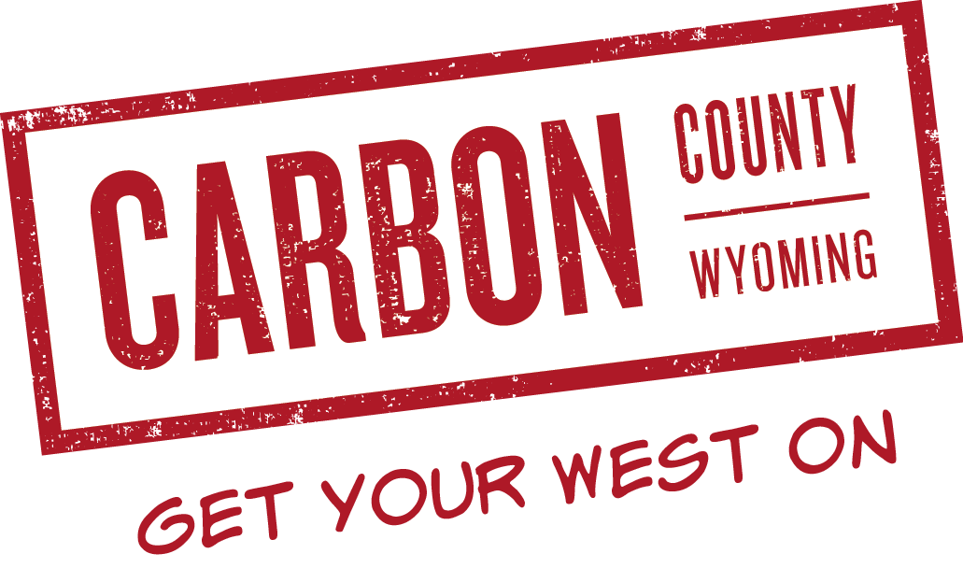CASH AWARD PRIZE RECEIPT

Carbon County Visitors Council (CCVC)

www.wyomingcarboncounty.com

I ____________________________________ hereby swear and verify that I have
won a $_________ cash award for (place & contest) _________________________ during the (event)_______________________________________________,
held on (date)_________________________, 20 ___________.
This cash award was made possible by a grant from the Carbon County Visitors’ Council and the 2% lodging tax!
________________________________________________________
cut along dotted line WINNER receives TOP portion and the CCVC gets the BOTTOM portion with claim form

Signature of cash award winner________________________________
Date_______________________

Please print
Recipient’s Name______________________________________________________________
Address______________________________________________________________________
City/State/Zip_________________________________________________________________
Phone or E-mail________________________________________________________________
Amount of cash award__________________Event____________________________________

Signature of Non-Profit Organization’s Chairman_____________________________________
Date____________________________________

Carbon County Visitors’ Council
PO Box 1017
Rawlins WY 82301
info@wyomingcarboncounty.com

